Experiment :-. 1.1

Student Name : Himangi Bhatt UID: 23BCC70020
Branch : CSE (Cloud Computing) Section/Group: A
Semester : 6th Date of Performance: 8/1/26
Subject Name : Building & Release Management Subject Code : 23CSH-395

Aim/Overview of the practical:
The objective of this practical is to install Git and set up a local repository in order to begin using version control.

Task to be done:
Install Git on the system and create a local Git repository to enable version control for a project.

Steps for Experiment/practical:
• Download Git from the official website (https://git-scm.com) and install it on the system.
• Configure the user information using the git config command.
• Open the terminal or command prompt and move to the directory of the project that requires version control.
• Initialize a new Git repository by executing the git init command.
• Add the required project files to the staging area using git add <filename> or use git add . to add all files.
• Commit the staged files to the repository with the command git commit -m "Initial commit".
• Verify the repository status and commit history using git status and git log.

Learning outcomes:
- To install Git and manage a repository for consistent version control.
- Students will be able to install Git, initialize a local repository, stage and commit files, and understand the basics of version control for collaborative software development.

Result: This program has been successfully executed.

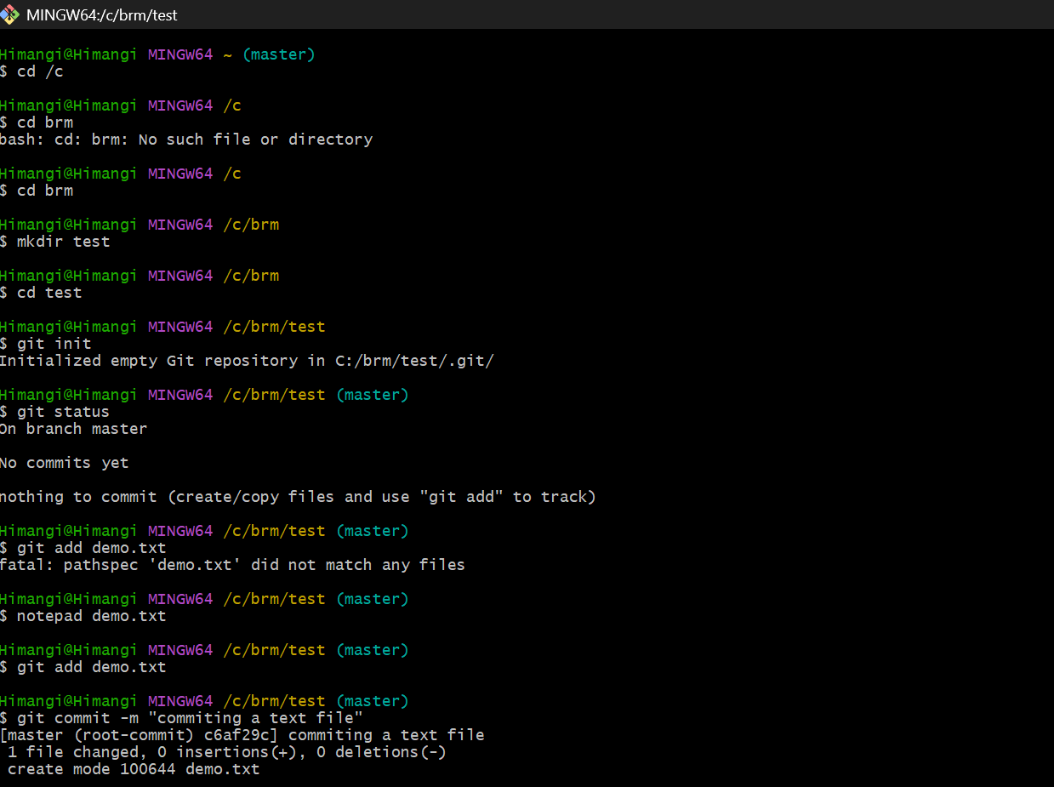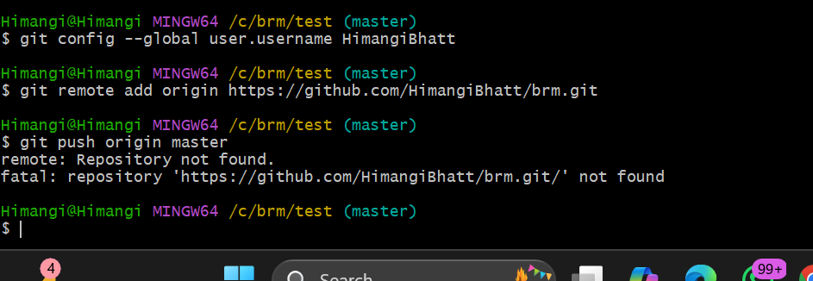

Evaluation Grid (To be created as per the SOP and Assessment guidelines by the faculty):

Sr. No. | Parameters | Marks Obtained | Maximum Marks
1.
2.
3.

- Viva Questions

  - What is Git and why is it used in software development?
  - What is the difference between a local repository and a remote repository?
  - How do you configure Git for the first time after installation?
  - What is the difference between git add and git commit?
  - How can you check the status of your Git repository?

Web Links:
  - Official Git Documentation
  - TutorialsPoint – Git Tutorial

